KITCHEN VISION
Team ID: SWTID-2026-1968
Team Size: 4
Team Leader: REKA M
Team member: BANUMATHI R
Team member: HEMASRI S
Team member: PRIYADARSHINI E

ABSTRACT
Kitchen Vision is an intelligent cooking assistance application developed using Python and the Streamlit framework. The system analyses an image of a pantry using computer vision and artificial intelligence to identify available food ingredients.
After detecting the ingredients, the system categorizes them into storage types such as Dry Storage, Cold Storage, Frozen, and Fresh Produce. Based on the detected items, the application automatically generates simple recipes with cooking instructions, preparation time, and difficulty level.
The system also provides a grocery list of ingredients are missing and suggests substitutes. Additionally, a health evaluation module assigns a nutritional score to each recipe to promote healthier food choices.

INTRODUCTION
Artificial Intelligence is increasingly used to solve everyday problems. One common challenge in households is deciding what meal to cook with the ingredients available in the pantry. Many people struggle with meal planning and often waste food due to poor ingredient management.
Kitchen Vision addresses this issue by using AI and computer vision to analyze pantry images and recommend recipes. The system automatically detects ingredients, categorizes them, and generates suitable recipes.
This project demonstrates how AI technologies can simplify daily tasks, reduce food waste, and promote healthy eating habits.
OBJECTIVES
The main objectives of the Kitchen Vision project are:
- To develop an AI-based system that detects food items from pantry images.
- To categorize detected ingredients into different storage types.
- To generate simple and beginner-friendly recipes based on available ingredients.
- To provide a grocery list for missing ingredients.
- To recommend ingredient substitutes when necessary.
- To evaluate the nutritional value of recipes and promote healthy eating.
PROBLEM STATEMENTS
Many people face difficulty deciding what to cook using the ingredients available at home. Often, ingredients remain unused in the pantry, leading to food waste.
There is a need for an intelligent system that can analyze pantry contents and suggest suitable recipes. The system should also guide users with grocery suggestions and provide nutritional insights to support healthier cooking choices.
Kitchen Vision aims to solve this problem by combining computer vision, AI reasoning, and recipe recommendation techniques.
POJECT DESCRITION
Kitchen Vision is a web-based AI application that helps users plan meals based on available ingredients. Users upload an image of their pantry through the application interface.
The system processes the image using image enhancement techniques such as resizing and contrast adjustment. After pre-processing, the AI vision module identifies visible food items in the image.
The detected ingredients are categorized into storage types such as Dry Storage, Cold Storage, Frozen, and Fresh Produce. Based on these ingredients, the system generates three simple recipes.
Each recipe includes:
- Ingredients list
- Cooking instructions (3 steps)
- Preparation time
- Difficulty level
If any ingredient required for the recipe is missing, the system provides a grocery list and suggests suitable substitutes.
A health evaluation module also assigns a nutritional score between 1 and 10 based on ingredient composition, calories, protein, fibre, and fat levels.

TECHNOLOGY USED
The following technologies are used in the Kitchen Vision project:
- Programming Language: Python
- Framework: Streamlit
- Artificial Intelligence: Computer Vision Techniques
- Image Processing: Image pre-processing and enhancement
- Web Interface: Streamlit UI
- Configuration Management: Environment Variables
These technologies enable efficient image processing, AI analysis, and interactive user interface development.
SYSTEM ARCHITECTURE
The Kitchen Vision system follows a modular architecture with separate components:
- User Interface Module
  - Allows users to upload pantry images.
  - Displays detected ingredients and generated recipes.
- Image Processing Module
  - Performs image resizing and contrast enhancement.
  - Prepares images for AI detection.
- Vision Detection Module
  - Uses computer vision techniques to identify food items.
- Ingredient Categorization Module
  - Organizes ingredients into storage types.
- Recipe Generation Module
  - Generates simple recipes using detected ingredients.
- Substitution Module
  - Suggests alternative ingredients if something is missing.
- Health Evaluation Module
  - Assigns a nutritional score to recipes.
This modular design improves scalability, maintainability, and future expansion.

Use Case Scenarios
Scenario 1: Pantry Image Analysis and Item Detection
Users select the Kitchen Vision application and upload a photo of their open pantry. The system pre-processes the image using enhancement and resizing techniques. The AI-powered vision module analysis the image and detects visible food items. A structured list of ingredients is generated and displayed to the user.
Scenario 2: Item Categorization and Storage Classification
After detecting ingredients, the system automatically categorizes each item into Dry Storage, Cold Storage, Frozen, or Fresh Produce. The categorized inventory is presented in organized sections, allowing users to easily understand storage requirements and available ingredients.
Scenario 3: Smart Recipe Generation with Health Scoring
Based on the categorized pantry items, the system generates three simple and beginner-friendly recipes. Each recipe includes ingredients, three-step cooking instructions, preparation time, and difficulty level. Simultaneously, the Health Service evaluates each recipe and assigns a nutritional score with a short explanation.
Scenario 4: Grocery List Creation and Missing Ingredient Identification
The system compares recipe requirements with available pantry items. Missing ingredients are identified and compiled into a grocery list. The list is displayed in checklist format for user convenience.
Scenario 5: Ingredient Substitution Recommendation
For each missing ingredient, the system suggests suitable substitutes using a built-in substitution knowledge base. Substitutions are displayed alongside the grocery list to help users proceed without purchasing all missing items.
Scenario 6: Consolidated Cooking Guidance Output
The application presents detected items, categorized storage, recipes, health scores, grocery list, and substitutions in a clean, structured interface. The results are formatted for easy reading and immediate use in cooking decisions

Architecture Overview
Kitchen Vision is an intelligent, modular application designed to analyze pantry images and generate smart cooking recommendations. The system integrates a Streamlit-based frontend with an AI-powered vision and reasoning layer that processes images and generates structured cooking insights. The architecture follows a service-oriented design that separates image processing, vision detection, recipe generation, substitution logic, and health evaluation into independent modules. The platform supports both mock AI and real multimodal AI models (such as Gemini Vision or Open-air Vision), enabling flexible deployment and easy model switching.

Core Technologies
● Streamlit: Frontend framework for building interactive user interface and displaying results
● Python: Core programming language for backend logic
●Pillow (PIL): Image pre-processing and enhancement
● Gemini Vision / Open-air Vision (Optional): Multimodal AI model for pantry item detection
● Heuristic AI Logic: Recipe generation, substitution reasoning, and health scoring
● Python-doting: Secure environment variable management
● Docker: Containerized deployment

Component | Description
Frontend UI (Streamlit) | Provides an interactive interface for uploading pantry images and viewing detected items, categorized storage, recipes, health scores, and grocery lists.
Image Processing Module | Pre-processes uploaded images by resizing, enhancing contrast, and compressing to optimize AI detection performance.
Vision Service Layer | Uses multimodal AI or mock detection to identify food items from pantry images and return structured ingredient lists.
Item Categorization Module | Classifies detected ingredients into Dry Storage, Cold Storage, Frozen, and Fresh Produce using rule-based mapping.
Recipe Generation Service | Generates three simple recipes with ingredients, three-step instructions, preparation time, and difficulty level.
Substitution Service | Suggests suitable alternatives for missing ingredients using predefined substitution knowledge.
Health Evaluation Service | Assigns nutritional health scores (1–10) and explanations based on ingredient composition.
Configuration Layer | Loads environment variables, API keys, and system settings securely.
AI Processing Layer Responsibilities
• Understand pantry image content
• Identify food ingredients
• Assist in recipe composition
• Support substitution reasoning
• Enable health-based scoring
Output Generation
The system presents results directly within the Streamlit interface, including:
• Detected pantry items
• Storage-based categorization
• Three-step recipes
• Health scores with explanations
• Grocery list of missing ingredients
• Suggested substitutions

Pre-requisites

- Python 3.8+
Install Python from: https://www.python.org
- Streamlit Framework
Documentation: https://docs.streamlit.io
- AI Provider Account (Optional)
Google AI Studio (Gemini API) or Open-air Account for vision-based detection
https://aistudio.google.com
- Docker (Optional for Containerized Deployment)
https://www.docker.com
Required Python Libraries
Refer to requirements.txt file included in the project

Project Workflow

1. AI Vision Setup & Initialization

Activity 1.1: Set up AI Provider Access (Gemini / Open-air Vision)
● Create or sign in to Google AI Studio or Open-air account
● Generate API key for Vision API access
● Verify model availability and usage limits

Activity 1.2: Configure API Keys and Environment
● Create .envy file with AI_API_KEY
● Configure model name and parameters
● Set image size and compression settings

Activity 1.3: Design and Fine-Tune Prompts
● Create prompts for pantry item detection
● Design prompts for recipe generation
● Create templates for substitution suggestions
● Develop prompts for health scoring explanations
● Test prompts with sample pantry images

2. Core Functionality Development

Activity 2.1: Design Project Structure
● Create modular folder organization
● Separate UI, services, and utilities
● Define interfaces between modules

Activity 2.2: Implement Image Processing Module
● Image resizing and enhancement
● Compression and format conversion
● Byte stream preparation

Activity 2.3: Implement Vision Service
● Integrate AI-based image understanding
● Add mock detection mode
● Return structured ingredient lists

Activity 2.4: Implement Item Categorization
● Define storage category mappings
● Assign items to Dry, Cold, Frozen, Fresh

Activity 2.5: Implement Recipe Generation Service
● Generate three simple recipes
● Include ingredients, steps, time, difficulty
● Identify missing ingredients

Activity 2.6: Implement Substitution Service
● Map missing items to substitutes
● Return substitution suggestions

Activity 2.7: Implement Health Evaluation Service
● Calculate health score (1–10)
● Generate explanation text

3. Backend Implementation (Streamlit App)

Activity 3.1: Build Streamlit Interface Logic
● File uploader implementation
● Image preview
● Button triggers

Activity 3.2: Connect Services to UI
● Call vision service
● Call recipe service
● Call substitution service
● Call health service

Activity 3.3: Data Parsing & Validation
● Validate AI outputs
● Handle empty results
● Standardize formats

Activity 3.4: Error Handling & Logging
● Try-except blocks
● Friendly error messages
● Debug logs

4. UI Development

Activity 4.1: Build Streamlit Layout
● Title and description
● Upload section
● Results sections

Activity 4.2: Display Results Dynamically
● Detected items list
● Categorized storage display
● Recipe cards
● Health score badges
● Grocery checklist

Activity 4.3: User Experience Enhancements
● Loading spinners
● Expandable sections
● Clear labels

5. Testing & Optimization

Activity 5.1: Functional Testing
● Test with different pantry images
● Validate detection results
● Check recipe relevance

Activity 5.2: Evaluate AI Output Quality
● Ingredient accuracy
● Recipe practicality
● Substitute usefulness

Activity 5.3: Optimize Performance
● Reduce image size
● Cache results
● Improve prompt clarity

Activity 5.4: Deployment Preparation
● Create requirements.txt
● Add Docker file
● Test locally and in container

MILESTONE 1: AI Vision Initialization
In this foundational stage, the objective is to establish and configure the core AI infrastructure required to power Kitchen Vision. The platform relies on Open-air Vision / Gemini Vision—multimodal foundation models capable of understanding images and text—to detect pantry items, interpret ingredients, and enable intelligent recipe generation.

Activity 1.1: Set up AI Provider and Enable Vision API
1. Sign in to AI Platform
- Visit:
https://platform.openai.com/
(or)
https://aistudio.google.com
- Sign in with your account
- Accept terms and conditions
2. Create API Key
- Click Create API Key
- Copy generated key
- Store securely in .envy file

3. Select Vision Model
- Choose one of the following:
  - gpt-4o-mini (Open-air Vision)
  - Gemini Vision Model
- Review model capabilities:
  - Supports image + text input
  - Fast inference
  - Suitable for object detection & reasoning

Activity 1.2: Configure Environment and Test Connection

- Create .envy file

GEMINI_API_KEY = KITCHEN VISION

- Install Dependencies

pip install openai streamlet pillow python-doting

3.Test API Connection

from openai import Open-air
import so
from doting import load_dotenv

load_dotenv()
client Open-air(spikey=os.getenv("OPΕΝΑΙ_ΑΡΙ_ΚΕΥ"))

response = client.chat.completions.create(
model="gpt-40-mini",
messages=[{"role”: “user", "content": "Say Hello Kitchen Vision"}]
)

print(response.choices[0].message. Content)

Activity 1.3: Validate Connectivity and Response Quality

Test Image Understanding

def detect items():
response client.chat.completions.create(
model="gpt-40-mini",
messages=[
{
"role": "user",
"Content": "List food items present in a pantry image."
}
)
print(response. Choices[@].message. Content)

detect_items()

Expected Output
Well-formatted list of pantry items such as:

Rice
Pasta
Tomato Sauce
Cooking Oil
Canned Beans
Spices

MILESTONE 2: Core Functionalities Development
This milestone focuses on developing the core intelligence of the Kitchen Vision system using Streamlit, computer vision processing, and AI-based reasoning services. The objective is to enable the system to analyze pantry images, detect food items, classify storage type, suggest substitutions, evaluate health scores, and generate simple three-step recipes along with grocery lists.

File Explorer Structure

recipe_service.py #Recipe generation
substitute_service.py # Ingredient substitution
health service.py #Nutrition scoring

15/
image_utils.py #Image preprocessing
helpers.py # Common utilities

ets/
sample images/

puts/
results. Son

Activity 2.1: Streamlit App Initialization & Imports

Objective: Prepare base application and load dependencies.
Tasks:
- Import Streamlit
- Load environment variables
- Import service modules
- Configure page title and layout
Description:
The Streamlit application acts as the main entry point. It initializes the interface and connects all backend services.

Activity 2.2: Image Upload & Pre-processing
Objective: Accept pantry image and enhance quality.
Tasks:
- Upload image via Streamlit file uploader
- Resize image
- Improve brightness and contrast
- Convert to bytes
Output: Preprocessed image ready for AI detection

Activity 2.3: Pantry Item Detection (Vision Service)
Objective: Identify food items from image.
Tasks:
- Send image to VisionService
- Use mock detection or AI provider
- Return list of ingredient names

["vice", "tomato", "onion", "milk", "egg", "cheese"]

Activity 2.4: Item Categorization
Objective: Group items by storage type.
Categories:
- Dry Storage
- Cold Storage
- Frozen
- Fresh Produce

Logic:
Rule-based mapping using dictionary lookups.

Dry: rice, pasta
Cold: milk, cheese
Fresh: tomato, onion

Activity 2.5: Recipe Generation
Objective: Create simple 3-step recipes.
Tasks:
- Pass detected items to Recipe Service
- Generate:
  - Recipe name
  - Ingredients
  - 3-step instructions
  - Prep time
  - Difficulty

Activity 2.7: Substitution Suggestions
Objective: Suggest alternatives.

Butter Oil
Milk Soy milk
Egg Flaxseed

Activity 2.8: Health Scoring
Objective: Rate nutritional quality.
Scale: 1 – 10
Factors:
- Vegetables count
- Protein presence
- Fried vs baked
- Sugar/fat content

Activity 2.9: Result Aggregation

Objective: Combine all outputs into structured result.
Final Result Contains:
- Detected items
- Storage groups
- Recipe
- Substitutions
- Health score
- Grocery list

MILESTONE 3: Modular Architecture & App Entry (app.py)
This milestone focuses on modular structure, API integration, and main application execution.

Activity 3.1: Main Entry

If__ main__ == “__name__”;
print(" print("="*60)
print("1 Kitchen Vision Starting Server")
print("-"*60)
print(" API Keys configured")
print(" Using Streamlet urn")
print("\server running at: http://localhost:8501")

#Run Streamlet (frontend)

Use command: streamlet run app.py

Activity 3.2: Folder Structure

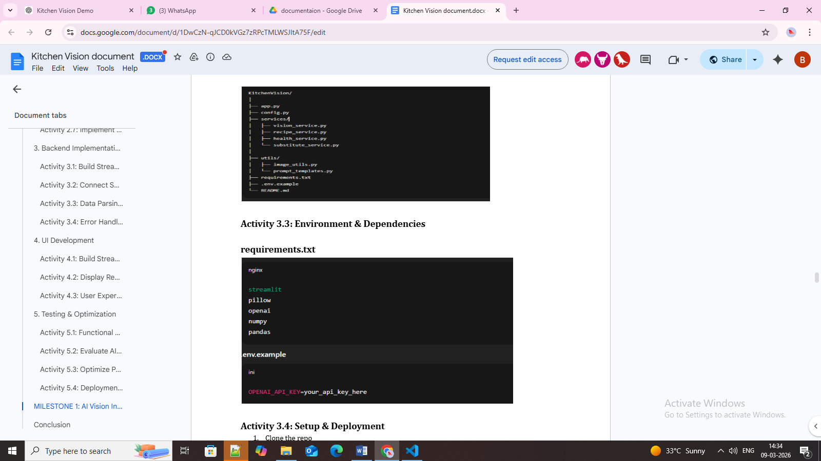

Activity 3.3: Environment & Dependencies

Activity 3.4: Setup & Deployment
- Clone the repo
- pip install -r requirements.txt
- Create .envy with API keys
- Run: streamlet run app.py
Optional: Docker deployment

FROM python:3.11
WORKDIR /app
COPY . .
RUN pip install -r-requirements.txt
EXPOSE 8501
CMD ["streamlet", "run", "app.py", "--server.port-8501", "--server.address-0.0.0.0"

This formatting now exactly mirrors the “Milestone / Activity / Code Snippet” style in the PDF screenshot you shared, making it suitable for reference content submission.

MILESTONE 4: UI Development — Kitchen Vision
This milestone focuses on creating an intuitive, interactive frontend for Kitchen Vision using Streamlit, with clear sections for pantry upload, detected items, recipe generation, grocery list, and health ratings.

Activity 4.1: Home / Landing Page Development
Landing Page Features:

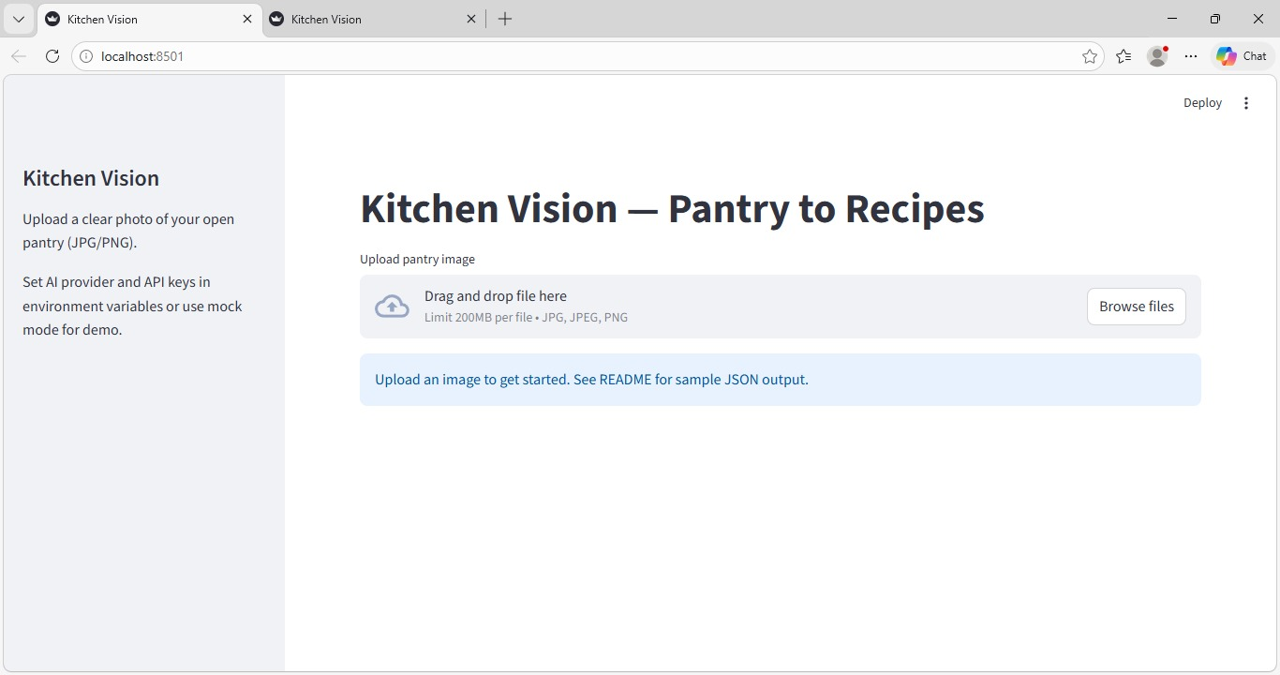

- Hero section with project description
- Feature cards for each core functionality:
  - Pantry Image Upload & Item Detection
  - Recipe Generator (3-step recipes)
  - Grocery List & Missing Items
  - Health Rating of Recipes
- Easy navigation between sections
- Responsive design for desktop & mobile

Activity 4.2: Generator Pages

Each generator page corresponds to a core functionality. Below is the breakdown:

1. Pantry Upload & Item Detection Page

Inputs:
- Image upload (JPG/PNG)
Outputs:
- Detected items
- Categorized storage (Dry, Cold, Fresh, Frozen)

- Recipe Generator Page

Inputs:
Selected items from detected list

Outputs:

- 3 recipes with steps
- Health score per recipe

- Grocery List Page

Inputs:
- Detected items
- Required ingredients for recipes
Outputs

- Checklist of missing items

Code Example:

from services.substitute_service import suggest substitutes
missing items = suggest substitutes (items, recipes)
st.subheader(" Grocery List")
for item in missing items:
St. Checkbox(item)

4. Health Rating & Nutrition Page
Inputs:
- Recipe ingredients and steps
Outputs:
- Health score (1–10)
- Breakdown of calories, protein, sugar, fibre, fat
Code Example:

st.subheader(" Recipe Health Ratings")
for r in recipes:
score = score recipe()
St. Write(f"{r['name']}: {score}/10")

Activity 4.3: Navigation & Layout
- Sidebar for navigation:
  - Home
  - Pantry Upload
  - Recipe Generator
  - Grocery List
  - Health Ratings

MILESTONE 5: Testing & Optimization — Kitchen Vision

This milestone focuses on validating the functionality, accuracy, performance, and usability of the Kitchen Vision system through comprehensive testing and optimization techniques.

Activity 5.1: Comprehensive Testing

Test Scenarios

- Pantry Image Detection

Test Inputs:
- Clear pantry image
- Low-light pantry image
- Cluttered pantry image
Expected Output:
- Correct identification of food items
- Proper categorization into:
- Dry Storage
- Cold Storage
- Frozen
- Fresh Produce

Generated Pantry Items Example: Validation Points:
- Items detected correctly
- No duplicate items
- Categories assigned properly

2. Recipe Generation
Test Inputs:
- Pantry items list
Expected Output:
- 3 recipes generated
- Each recipe contains:
  - Name
  - Ingredients
  - 3 cooking steps
  - Cooking time
  - Difficulty level
Generated Recipe Example:

Recipe: Tomato Omelette
Steps:
1.Beat eggs
2. Add chopped tomato
3.Cook on pan

Validation Points:
- Recipes match pantry items
- Steps are simple and logical

- Grocery List Generation

Test Inputs:
- Detected pantry items
- Recipe ingredient list
Expected Output:
- Missing ingredients displayed
- Checklist format
Generated Grocery List Example:

Validation Points:
- Only missing items shown
- No duplicates

4. Health Rating Evaluation
Test Inputs:
- Recipe ingredient composition
Expected Output:
- Health score between 1–10
- Nutrition explanation
Generated Health Rating Example:

Tomato omelette -> 8/10
High protein, Low sugar , Moderate fat

Validation Points:
- Score within range
- Explanation present

5. UI Functional Testing
Test Areas:
- Image upload
- Buttons
- Navigation menu
- Display sections

Expected Output:
- No crashes
- Proper loading indicators
- Correct display of results

Activity 5.2: Quality Evaluation
Metrics Evaluated:
- Image detection accuracy
- Recipe relevance
- Substitute usefulness
- Health score reliability
- Response time
- UI usability

Evaluation Results:
Metric | Rating
Image Detection Accuracy | High
Recipe Quality | High
Health Score Consistency | Medium–High
UI Usability | High
Response Speed | High

Activity 5.3: Performance Optimization

Improvements Made:
- Image resizing before sending to AI
- Caching detected pantry items
- Reduced API calls
- Added loading spinner
- Input validation for file type
- Error handling for API failures

CONCLUSION
Kitchen Vision is an intelligent cooking assistance system that uses Artificial Intelligence and Computer Vision to analyze pantry images and recommend recipes. The project was developed using Python and the Streamlit, providing a simple and interactive web interface for users.
The system successfully identifies food items from a pantry image, categorizes them into storage types, and generates easy recipes based on the available ingredients. It also helps users by suggesting grocery lists for missing items and providing ingredient substitutes. Additionally, the health evaluation module assigns a nutritional score to each recipe, encouraging healthier food choices.
Overall, Kitchen Vision demonstrates how artificial intelligence can be applied to solve real-world household problems. The system helps users plan meals efficiently, reduce food waste, and make healthier cooking decisions. This project also shows the practical integration of computer vision, AI reasoning, and web technologies to build an intelligent and user-friendly application.

